- Our Strategy for R2RML Mapping Generation
  - Overview
In this section, we present our approach for the automatic generation of customized R2RML mappings for converting relational data to the target vocabulary of a given domain ontology.
Figure 5 illustrates the main steps of our strategy. The process inputs are:
- D = (V_{D}, C_{D}): the domain ontology
- S: the data source schema that must be mapped to D
- A: a set of correspondence assertions between S and D
As shown in Figure 5, the mapping generation process consists of two main steps. The first step involves the design of the exported ontology E = (V_{E}, C_{E}), which models the RDF view exported by the data source. The vocabulary V_{E} of the exported ontology is a subset of V_{D}, which can be automatically generated based on the matching assertions between the D and S [12].
The second step involves the design of: (i) a set of relational view schemas V, where V is a direct transformation for the exported ontology E; and (ii) a R2RML mapping M which maps V to E. The views schemas in V can be implemented as SQL views or R2RML views. In Section 4.2, we present an algorithm that automatically generates V and M from the process inputs.
The benefits of using relational views as a middle layer are twofold: (i) given that V is a direct transformation of E, the mapping M can be automatically generated based on V; (ii) it becomes easier to change the R2RML mapping M to accommodate changes to the database view schemas.

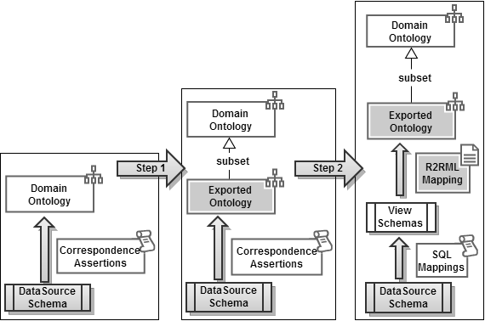
Fig. 1. R2RML Mapping Generation Process
  - Step 1: Design of the Exported Ontology
The design of the exported ontology depends on what we require from the data exported by the data source. As proposed in [xx], we require the exported ontology be an open or a closed fragment of the domain ontology.
Again, let D = (V_{D}, C_{D}) denote the domain ontology and E = (V_{E}, C_{E}) denote the exported ontology. Assume that V_{E} is a subset of V_{D}. Then, E = (V_{E}, C_{E}) can be automatically generated, based on the correspondence assertions between the D and S [xx]. Briefly, a term T (class or property) of V_{D} is in V_{E} if and only if there is a matching assertion for T in A. The constraints C_{E} are generated using the procedure openFragment introduced in [xx].

Consider, for example, the ISWC_REL database schema in Figure 1, the CONF_OWL Domain Ontology in Figure 2 and the correspondence assertions in Figure 3. Figure 6 shows the exported ontology ISWC_RDF. The vocabulary of ISWC_RDF contains all the elements of the ISWC ontology that matches an element of ISWS_REL. The constraints are generated using the procedure openFragment introduced in [xx].
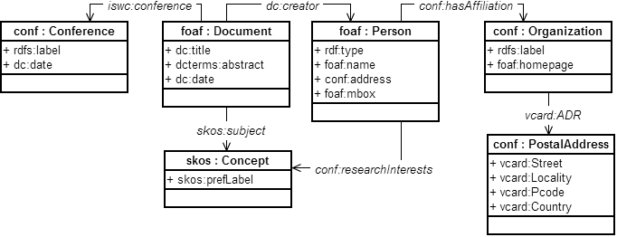
Fig. 2. ISWC_RDF Exported Ontology Schema
  - Step 2: Design of relational view schemas and R2RML mappings
Table 6 shows the procedure to generate the relational view schemas and R2RML mappings. The procedure has 3 main steps:
- Creates a relational view C for each class pc:C in the exported ontology E. The primary key of each view is also created as an attribute ID that is a surrogate key. The mapping of this view is created as a header mapping and contains the logical table C, the template for the URI of pc:C individuals and the target class pc:C. For instance, we should consider class foaf:Person. This step will generate the relational view Person with an attribute ID as primary key in the ISWC_View schemas and line 1 of Table 12 in the R2RML mapping.
- This step handles the datatype properties in E and is divided into 2 cases:
  - The datatype property pp:P has maxCardinality equal to 1. In this case, a simple attribute P is created in the relational view D. This view was created during the execution of Step 1 for the class pd:D that is the domain of pp:P. The database type of P is according to range of pp:P. A simple predicate map is created to map P to pp:P. As an example consider datatype property foaf:mbox whose domain is foaf:Person. The procedure will create the attribute mbox into view Person (created in Step 1) and the predicate map in line 2 of Table 12.
  - The datatype property pp:P has maxCardinality is greater than 1. A simple attribute is not sufficient to implement this case. Then the procedure creates a new relational view D_P to persist the multiple values of property pp:P, an attribute ID_D as foreign key to view D, an attribute P for the value of pp:P, and the triples map to generate triples in the form: pd:D (subject) pp:P (predicate) value of attribute P (object).
- This last step handles the object properties in E and is also divided into 2 cases:
  - The object property pp:P has maxCardinality equal to 1. The procedure creates an attribute ID_R in view D (created in Step 1 for the domain class of pp:P) as a foreign key to view R (created in Step 1 for the range class of pp:P) and a predicate object map with a join condition using this foreign key. In the running example there is the object property iswc:conference which has foaf:Document as domain and conf:Conference as range. The procedure generates attribute ID_Conference into view Document as a foreign key to view Conference and the predicate object map in line X of table 12.
  - The object property pp:P has maxCardinality greater than 1. A simple attribute as foreign key is not sufficient to implement this case. Then the procedure creates a new relational view D_P which is a link table between views D (created in Step 1 for the domain class of pp:P) and R (created in Step 1 for the range class of pp:P), attributes ID_D and ID_R as foreign keys to views D and R respectively, and the triples map to generate triples in the form: pd:D (subject) pp:P (predicate) pr:R (object). In our example we have four relationships that illustrate this case. For instance, consider the object property iswc:research_interests which has foaf:Person as domain and skos:Concept as range. The procedure creates the link table Person_Research_Interests that comprises two attributes ID_Person and ID_Concept as foreign keys. Finally, line 7 of Table 12 is included in the R2RML mapping in this step.
Figure 13 depicts ISWC_Views, the relational view schemas for exported ontology ISWC_RDF, and Figure 14 contains some of the R2RML mappings for converting ISWC_Views data to the ISWC_RDF vocabulary.
Using the procedure presented in Table 6 to transform the ISWC_RDF ontology to relational we obtain the relational view schema ISWC_Views presented on Figure 7 and the R2RML mapping between the ISWC_Views schema and ISWC_RDF ontology is shown in Table 12.
Table 1. Procedure to generate the relational view schemas and R2RML mappings
Input: Exported Ontology E
Output: a set V of relational view schemas and a mapping M of R2RML mapping from V to E.
Step 1: For each class pc:C in V_{E} do
- Create a relational view C;
- Create attribute ID as primary key of C;
- Create the subject map for relational view C;
Step 2: For each datatype property pp:P in V_{E} do
- Let pd:D be the domain class of pp:P;
- In Case of:
Case 2.1: pp:P has maxCardinality equal to 1.
- Create attribute P in view D whose type is defined according to range of pp:P;
- Create a predicate map for pp:P;
Case 2.2: pp:P has maxCardinality greater than 1.
- Create intermediate relational view D_P;
- Create attribute ID_D in D_P defined as a foreign key to D (parent table);
- Create attribute P in D_P whose type is defined according to range of pp:P;
- Create subject and object map for relational view D_P.
Step 3: For each object property pp:P in E do
- Let pd:D and pr:R be the domain and range of pp:P, respectively;
- In case of:
Case 3.1: pp:P has maxCardinality equal to 1.
- Create attribute ID_R in table D which is a foreign key to R (parent table);
- Create an object map for relational view D.
Case 3.2: pp:P has maxCardinality greater than 1.
- Create intermediate table D_P;
- Create attribute ID_D in D_P which is a foreign key to D;
- Create attribute ID_R in D_P which is a foreign key to R;
- Create subject and object map for relational view D_P
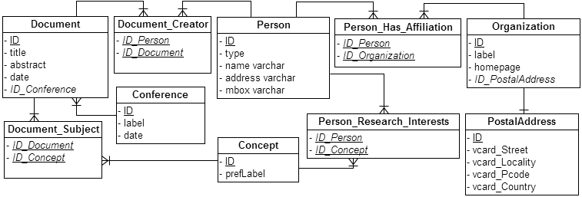
Fig. 3. ISWC_View Schemas
Table 2. R2RML Mapping Generated
1 | <#PersonTriplesMap>  rr:logicalTable [ rr:tableName "Person" ];  rr:subjectMap [  rr:template "person/{id}";  rr:class foaf:Person;  ];
2 | rr:predicateObjectMap [  rr:predicate foaf:mbox;  rr:objectMap [ rr:column "mbox" ];  ];
3 | ...
4 | <#ConceptTriplesMap>  rr:logicalTable [ rr:tableName "Concept" ];  rr:subjectMap [  rr:template "concept/{id}";  rr:class skos:Concept;  ];
5 | rr:predicateObjectMap [  rr:predicate skos:prefLabel;  rr:objectMap [ rr:column "prefLabel" ];  ];
6 | ...
7 | <#Person_Research_InterestsTriplesMap>  rr:logicalTable [  rr:tableName “Person_Research_Interests”  ];  rr:subjectMap [  rr:template "person/{id_person}";  ];  rr:predicateObjectMap [  rr:predicate iswc:research_interests;  rr:objectMap [  rr:parentTriplesMap <#ConceptTriplesMap>;  rr:joinCondition [  rr:child "id_concept ";  rr:parent "id";  ];  ];  ].

